Library Resource Management System
Portfolio Report

Module:
Fundamentals of Data Science
Assessment:
Coursework Portfolio
Prepared By:
Abhipsha Bhandari (Lead Developer)
Angel Darlami Magar
Rasmila Tamang
Academic Year:
2026
Submission Date:
15 July 2026

Table of Contents
- Introduction ...............................................................................................……….2
- Project Objectives ............................................................................................... 3
- Project Requirements .......................................................................................... 4
- Technologies Used .............................................................................................. 6
- System Design .................................................................................................... 7
- Project Structure .................................................................................................9
- Object-Oriented Programming (OOP) Implementation ........................................11
- Role-Based Access Control ................................................................................14
- Data Storage and File Management ....................................................................16
- System Implementation .....................................................................................19
- Exception Handling and Error Management ........................................................ 22
- System Testing and Results ................................................................................ 24
- Sample Input and Output ................................................................................... 26
- GitHub Repository and Version Control .............................................................. 29
- Teamwork Contribution and Roles .......................................................................31
- . Individual Reflection ........................................................................................33
- Challenges Faced and Solutions .........................................................................35
- Future Improvements and Enhancements .......................................................... 37
- Conclusion .......................................................................................................39
- References .......................................................................................................40
- Appendices .......................................................................................................41

1. Introduction
The Library Resource Management System (LRMS) is a Python-based application developed to simplify and automate the daily operations of a library. The system provides an efficient way to manage books, library members, and borrowing records while reducing the need for manual record keeping. It is designed using Object-Oriented Programming (OOP) principles and follows a modular structure to improve code organization, readability, and maintainability.
The project allows librarians to manage the library by adding, updating, and removing books, maintaining member records, and monitoring borrowed books. Students can securely log in to search for books, borrow and return available resources, view their current loans, and update their personal information. User authentication is implemented using hashed passwords to improve security, while data is stored in text files to ensure persistence between program executions.
This project was developed as part of the Fundamentals of Data Science (UFCFK1-15-0) module to demonstrate the practical application of Python programming concepts, including classes, inheritance, file handling, exception handling, modular programming, and role-based access control. Throughout the development process, emphasis was placed on creating a reliable, user-friendly, and maintainable system that meets the functional requirements of the assessment.
Overall, the Library Resource Management System demonstrates how programming and data management techniques can be applied to solve real-world problems by providing an organized, secure, and efficient solution for managing library resources.

2. Project Objectives
The primary objective of the Library Resource Management System is to develop a reliable and user-friendly application that automates the management of library resources using Python. The system is designed to improve efficiency, reduce manual work, and provide secure access for both librarians and students.
The specific objectives of the project are:
- To develop a digital system for managing library books and member records.
- To implement secure user authentication using hashed passwords.
- To provide role-based access for Librarians and Students.
- To allow librarians to add, update, remove, and manage book records.
- To enable students to search, borrow, and return books efficiently.
- To maintain accurate records of books, members, and borrow transactions using text files.
- To apply Object-Oriented Programming (OOP) concepts such as classes, objects, inheritance, and encapsulation.
- To implement exception handling for invalid inputs and system errors.
- To design the program using modular functions for better readability, maintainability, and code reusability.
- To develop a practical system that meets the requirements of the Fundamentals of Data Science coursework.

3. Project Requirements
The Library Resource Management System was developed according to the requirements specified in the coursework. The system includes the following functional and technical features.
3.1 Functional Requirements
The system allows users to:
- Securely log in using a username and password.
- Manage books by adding, updating, searching, and removing book records.
- Register and manage library members.
- Borrow and return books.
- Store and retrieve data using text files.
- View and update user information based on their role.
3.2 Role-Based Access
Librarian (Admin)
The librarian has permission to:
- Add new books.
- Remove or update existing books.
- Manage member records.
- View borrowing records and library data.
Student (User)
The student can:
- Search for available books.
- Borrow and return books.
- View current borrowed books.
- Update personal profile information.
3.3 Technical Requirements
The project was implemented using the following programming concepts:
- Python programming language
- Object-Oriented Programming (OOP)
- Classes and inheritance
- Modular programming using functions
- Exception handling for invalid inputs
- File handling for persistent data storage
- Password hashing for secure authentication
3.4 Data Storage
The system stores information using four text files:
- books.txt – Stores book title, author, ISBN, quantity, and availability.
- members.txt – Stores member information and user roles.
- loans.txt – Stores borrowing records, issue dates, and return information.
- passwords.txt – Stores usernames and encrypted (hashed) passwords for secure login.

4. Technologies Used
The Library Resource Management System was developed using Python and follows a modular and object-oriented approach. The technologies and tools used during the development of the project are described below.
Technology / Tool | Purpose
Python 3 | Primary programming language used to develop the application.
Object-Oriented Programming (OOP) | Used to organize the program into classes and objects for better maintainability and code reuse.
Text Files (.txt) | Used to store books, members, loans, and login credentials permanently.
Hashlib | Used to hash user passwords, improving the security of the login system.
OS Module | Used to manage file paths and ensure the program accesses data files correctly.
Visual Studio Code (VS Code) | Integrated Development Environment (IDE) used for coding, testing, and debugging.
Git | Used to track changes and manage the project's version history.
GitHub | Used as an online repository for version control, collaboration, and project backup.

Why These Technologies?
Python was selected because of its simple syntax, readability, and strong support for object-oriented programming and file handling. Text files were used as the storage medium because they satisfy the coursework requirements and are easy to implement without requiring a database. Git and GitHub were used to maintain version control throughout the development process, while VS Code provided an efficient environment for writing, testing, and debugging the application.
5. System Design
5.1 System Overview
The Library Resource Management System is designed as a modular Python application that manages library operations through different components. The system follows an organized structure where each module performs a specific responsibility, making the program easier to develop, test, and maintain.
The system consists of several main modules:
- Authentication Module – Handles user login and password verification.
- Book Management Module – Manages adding, updating, searching, and removing books.
- Member Management Module – Handles registration and management of library users.
- Loan Management Module – Controls book borrowing and returning activities.
- Storage Module – Handles reading and writing data from text files.
- Exception Handling Module – Manages invalid inputs and prevents system errors.

5.2 System Architecture
The overall architecture of the system is shown below:
User
|
Login System
|
Authentication Module
|
Role-Based Access Control
/ \
/ \
Librarian Student
| |
Book Management Book Search
Member Management Borrow Books
Reports Return Books
\ /
\ /
Storage Layer
|
------------------------------------------------
books.txt | members.txt | loans.txt | passwords.txt
------------------------------------------------

5.3 System Workflow
The system follows the following workflow:
- The user starts the application.
- The user enters login credentials.
- The system verifies the username and hashed password.
- The system identifies the user's role.
- The user accesses features according to their permissions.
- The selected operation is performed.
- Updated information is saved into the relevant text files.
- The user can continue using the system or log out.

5.4 Design Approach
The project uses a modular design approach where different functionalities are separated into individual files. This improves:
- Code readability
- Reusability
- Debugging efficiency
- Future system expansion
The design follows Object-Oriented Programming principles, allowing different entities such as books, users, and library operations to be represented as classes and objects.

6. Project Structure
The Library Resource Management System follows a modular file structure where each Python file is responsible for a specific part of the system. This approach improves code organization, readability, and maintainability.
The project structure is shown below:
Library Resource Management System
│
├── main.py
├── book.py
├── member.py
├── library.py
├── storage.py
├── login.py
├── exceptions.py
│
└── data/
├── books.txt
├── members.txt
├── loans.txt
└── passwords.txt
Description of Project Files
main.py
The main entry point of the application. It controls the program execution flow, displays menus, and connects different modules together.

book.py
Contains the Book class, which represents book-related information such as title, author, ISBN, and availability status. It includes methods for managing book details.
member.py
Contains the User/Member class, which manages library member information such as username, role, and personal details.
library.py
Contains the main library management logic. It handles operations such as adding books, searching books, borrowing books, returning books, and managing library records.
storage.py
Responsible for handling data persistence. It manages reading and writing information from text files such as books, members, loans, and passwords.
login.py
Handles user authentication by validating login credentials and comparing hashed passwords.
exceptions.py
Contains custom exception classes used to handle invalid inputs and prevent unexpected program errors.

Data Folder
The data folder stores all permanent records required by the system.
File | Purpose
books.txt | Stores book details and availability information
members.txt | Stores registered member details and roles
loans.txt | Stores borrowing and returning records
passwords.txt | Stores encrypted login credentials
This modular structure allows each component of the system to work independently while maintaining communication between modules.

7. Object-Oriented Programming (OOP) Implementation
The Library Resource Management System was developed using Object-Oriented Programming (OOP) principles. OOP helps organize the code by representing real-world entities such as books, users, and library operations as classes and objects. This improves code structure, reusability, and maintainability.
7.1 Classes Used in the System
Book Class
The Book class represents individual library books. It stores important attributes such as:
- Book title
- Author name
- ISBN
- Availability status
The class contains methods to display book information and manage book-related operations.

User/Member Class
The User class represents library members. It stores user-related information such as:
- Member ID
- Username
- Role (Librarian/Student)
- Personal details
This class allows the system to identify users and provide access based on their roles.

Library Class
The Library class manages the main operations of the system. It connects different components and provides functions for:
- Adding books
- Removing books
- Searching books
- Borrowing books
- Returning books
- Managing members

7.2 OOP Concepts Applied
Classes and Objects
Classes are used as templates to create objects. For example, each book stored in the system is created as a Book object with its own details.
Encapsulation
Data and related functions are grouped together inside classes. This protects the data and allows controlled access through methods.
Inheritance
Inheritance allows one class to reuse properties and methods from another class. It supports better code organization and reduces code duplication.
Example:
User
|
-------------------------
| |
Librarian Student
The Librarian and Student roles can inherit common user information while having different permissions.
Exception Handling
Custom exceptions are implemented to handle errors such as:
- Invalid login details
- Empty inputs
- Incorrect book information
- Invalid user operations
This prevents the program from crashing and improves user experience.
Modularity
The system is divided into separate modules, where each file performs a specific task. This makes the code easier to understand, test, and modify.

The use of OOP principles ensures that the Library Resource Management System is structured, scalable, and easier to maintain for future improvements.

8. Role-Based Access Control
The Library Resource Management System implements role-based access control to provide different permissions for different types of users. The system has two main roles: Librarian (Admin) and Student (User). Each role has specific responsibilities and access privileges to ensure secure and organized system usage.

8.1 Librarian (Admin) Role
The Librarian has administrative privileges and is responsible for managing the overall library resources.
Librarian Functions:
- Secure login access.
- Add new books to the library collection.
- Remove unavailable or outdated books.
- Update existing book information.
- Manage member records.
- Monitor borrowing activities.
- Maintain accurate library data.
The Librarian role helps ensure that library resources remain updated and properly managed.

8.2 Student (User) Role
The Student role provides access to basic library services while restricting administrative functions.
Student Functions:
- Secure login access.
- Search available books.
- View book details.
- Borrow available books.
- Return borrowed books.
- View current loan records.
- Update personal profile information.
The Student role allows users to interact with library resources without modifying important system records.

8.3 Authentication Process
The system follows the following authentication process:
- User enters username and password.
- The system retrieves stored login credentials from passwords.txt.
- The entered password is converted into a hash value.
- The generated hash is compared with the stored password hash.
- If credentials match, access is granted.
- The user's role determines the available features.

8.4 Benefits of Role-Based Access
Implementing role-based access control provides:
- Improved security.
- Prevention of unauthorized modifications.
- Better user management.
- Controlled access to system features.
- Organized workflow between administrators and users.
This approach ensures that each user can only perform operations appropriate to their role.

9. Data Storage and File Management
The Library Resource Management System uses text files as a data storage method to maintain records permanently. This approach allows the application to save and retrieve information even after the program is closed. The storage system is managed through the storage.py module, which handles reading, writing, and updating data files.
The system uses four main text files:

9.1 books.txt
The books.txt file stores all information related to library books.
Stored Information:
- Book ID
- Book title
- Author name
- ISBN number
- Availability status
Purpose:
This file allows the system to:
- Display available books.
- Search for specific books.
- Update book information.
- Track book availability during borrowing and returning.

9.2 members.txt
The members.txt file stores information about registered library users.
Stored Information:
- Member ID
- Username
- Personal details
- User role (Librarian/Student)
Purpose:
This file helps the system:
- Identify users.
- Assign appropriate permissions.
- Manage member records.

9.3 loans.txt
The loans.txt file maintains borrowing transaction records.
Stored Information:
- Member information
- Borrowed book details
- Loan date
- Return status
- Due date (where applicable)
Purpose:
This file allows the system to:
- Track borrowed books.
- Record returns.
- Monitor current loans.

9.4 passwords.txt
The passwords.txt file stores user authentication information securely.
Stored Information:
- Username
- Hashed password
Security Implementation:
The system uses the hashlib library to convert plain-text passwords into hash values before storing them. During login, the entered password is hashed again and compared with the stored hash.
This improves security by ensuring that actual passwords are not stored directly.

9.5 Advantages of File-Based Storage
The text file storage approach provides:
- Simple implementation.
- Permanent data storage.
- Easy data access.
- Compatibility with Python file handling.
- No requirement for external database installation.
Although text files are suitable for this project, future versions could replace them with a database system such as MySQL or SQLite for improved scalability.

10. System Implementation
The Library Resource Management System was implemented using Python with a modular programming approach. Each module is responsible for a specific task, allowing the system to operate efficiently while maintaining clear separation between different functionalities.
The implementation combines Object-Oriented Programming, file handling, authentication, and exception handling to create a complete library management solution.

10.1 Login and Authentication Module
The login module provides secure access to the system by validating user credentials.
Process:
- User enters username and password.
- The system loads stored credentials from passwords.txt.
- The entered password is encrypted using hashing.
- The hashed password is compared with the stored value.
- Access is granted if the credentials match.
Security Features:
- Password hashing using hashlib.
- Validation of empty inputs.
- Authentication error handling.

10.2 Book Management Module
The book management module handles all operations related to library resources.
Main Functions:
- Add new books.
- View available books.
- Search books.
- Update book information.
- Remove books.
- Check availability status.
The module uses the Book class to represent each book as an object, making the system easier to manage and extend.

10.3 Member Management Module
The member management module manages library users.
Main Functions:
- Register new members.
- Store member information.
- Assign user roles.
- Update member details.
The system separates users based on their roles, allowing different levels of access.

10.4 Borrowing and Returning Module
This module manages the circulation of books between students and the library.
Borrowing Process:
- Student searches for a required book.
- System checks availability.
- Book status is updated.
- Loan record is created in loans.txt.
Returning Process:
- Student returns the borrowed book.
- The loan record is updated.
- The book availability status is changed.
- Updated information is saved.

10.5 Modular Programming Approach
The project is divided into multiple modules:
- Improves code organization.
- Makes debugging easier.
- Allows independent testing.
- Supports future improvements.
The modular design makes the application easier to maintain and expand with additional features such as database integration and graphical interfaces.

11. Exception Handling and Error Management
Exception handling is an important part of the Library Resource Management System as it helps the program manage unexpected situations and invalid user inputs without stopping execution. The system uses custom exceptions and validation techniques to improve reliability and user experience.

11.1 Purpose of Exception Handling
The main purposes of exception handling in this project are:
- Prevent program crashes caused by incorrect inputs.
- Provide meaningful error messages to users.
- Maintain data accuracy and consistency.
- Improve system reliability.

11.2 Custom Exception Handling
The project includes a separate exceptions.py module that contains custom exception classes.
Examples of errors handled include:
- Invalid username or password.
- Empty input fields.
- Incorrect book information.
- Invalid member details.
- Unauthorized operations.

11.3 Input Validation
The system validates user inputs before processing information.
Examples:
- Checking that usernames and passwords are not empty.
- Ensuring required book details are provided.
- Confirming that a book exists before updating or removing it.
- Checking book availability before borrowing.

11.4 Authentication Error Handling
During login, the system handles incorrect credentials by displaying appropriate error messages instead of allowing unauthorized access.
The authentication system ensures:
- Only registered users can access the system.
- Password verification is performed securely.
- Invalid login attempts are rejected.

11.5 Benefits of Error Management
Effective exception handling provides:
- Better user experience.
- Improved application stability.
- Easier debugging and maintenance.
- Protection against invalid data entry.
By implementing exception handling, the Library Resource Management System becomes more reliable and suitable for real-world usage.

12. System Testing and Results
System testing was performed to verify that the Library Resource Management System works correctly according to the specified requirements. Different test cases were created to check individual features, validate user inputs, and ensure that the system produces the expected results.
Testing was carried out on major functionalities including login, book management, member management, borrowing, returning, and file storage.

12.1 Test Cases
Test ID | Function Tested | Test Input | Expected Result | Actual Result | Status
T01 | User Login | Valid username and password | User successfully logs in | Login successful | Pass
T02 | User Login | Incorrect password | Display authentication error | Error message displayed | Pass
T03 | Add Book | Enter valid book details | New book added successfully | Book record created | Pass
T04 | Search Book | Enter existing book title | Display matching book details | Book found successfully | Pass
T05 | Borrow Book | Select available book | Book status updated and loan created | Borrow successful | Pass
T06 | Return Book | Return borrowed book | Book availability updated | Return completed | Pass
T07 | Invalid Input | Empty required fields | Display validation error | Error message displayed | Pass
T08 | File Storage | Restart application | Previous records remain available | Data loaded successfully | Pass

12.2 Testing Approach
The following testing methods were used:
Functional Testing
Used to verify whether each feature performs according to requirements.
Input Validation Testing
Used to ensure incorrect or empty inputs are handled properly.
Authentication Testing
Used to confirm that only valid users can access the system.
Data Persistence Testing
Used to check whether information is correctly stored and retrieved from text files.

12.3 Testing Outcome
The testing results show that the Library Resource Management System successfully performs its required operations. All major functionalities, including authentication, book management, member management, borrowing, returning, and file storage, worked correctly during testing.
The testing process also helped identify and fix errors related to file paths, input validation, and data handling, improving the overall reliability of the application.

13. Sample Input and Output
The following examples demonstrate the functionality of the Library Resource Management System. The sample outputs show how users interact with the system through different operations.

13.1 User Login
Input:
Enter username: librarian01
Enter password: ********
Output:
Login successful!
Welcome Librarian.
Access granted to administrative features.

13.2 Main Menu
After successful login, the user is presented with the available options.
Output:
========== Library Resource Management System ==========
1. Add Book
2. View Books
3. Search Book
4. Borrow Book
5. Return Book
6. Manage Members
7. Logout
Enter your choice:

13.3 Adding a New Book (Librarian)
Input:
Enter book title: Python Programming
Enter author name: John Smith
Enter ISBN: 978123456789
Enter availability: Available
Output:
Book added successfully.
Book information saved to books.txt

13.4 Searching for a Book (Student)
Input:
Enter book title: Python Programming
Output:
Book Found:
Title: Python Programming
Author: John Smith
ISBN: 978123456789
Status: Available

13.5 Borrowing a Book
Input:
Enter Book ID: B001
Confirm borrowing: Yes

Output:
Book borrowed successfully.
Loan record updated in loans.txt

13.6 Returning a Book
Input:
Enter Book ID: B00
Confirm return: Yes
Output:
Book returned successfully.
Book availability updated.

13.7 Data Storage Example
After performing operations, records are stored in text files:
books.txt
B001,Python Programming,John Smith,978123456789,Available
loans.txt
Student01,B001,Borrowed

These examples demonstrate that the system successfully handles user authentication, book management, and borrowing operations while maintaining permanent records through text file storage.

14. GitHub Repository and Version Control
The Library Resource Management System was managed using Git and GitHub to maintain the source code, track development progress, and provide a secure backup of the project files.
14.1 GitHub Repository
The project source code is hosted on GitHub:
Repository Link:
https://github.com/babhipsha/FODS-Project-Work
The repository contains all important project files, including Python source code, data files, and supporting modules required to run the application.

14.2 Purpose of Using GitHub
GitHub was used for:
- Storing and managing project source code.
- Tracking changes made during development.
- Maintaining different versions of the project.
- Providing easy access to project files.
- Supporting collaboration between team members.

14.3 Version Control Process
During development, Git was used to:
- Create and organize the project repository.
- Add new features and improvements.
- Track modifications to files.
- Review changes made during development.
- Maintain the final working version of the system.

14.4 Benefits of Version Control
Using GitHub provided several advantages:
- Reduced risk of losing project files.
- Easier collaboration between team members.
- Better organization of development work.
- Ability to monitor project progress.
- Professional software development practice.
The use of GitHub demonstrates the application of modern development practices and supports efficient project management.

15. Teamwork Contribution and Roles
The Library Resource Management System was developed as a team project where each member contributed towards the successful completion of the application. Team members were involved in different areas including development, testing, documentation, and project preparation.

15.1 Abhipsha Bhandari – Lead Developer
Abhipsha Bhandari was responsible for the main development and technical implementation of the project. Her contributions included:
- Designing the overall system structure and workflow.
- Developing the core Python modules.
- Implementing object-oriented programming concepts.
- Creating the authentication and login system.
- Developing book and member management functionalities.
- Implementing borrowing and returning operations.
- Managing file storage and data handling.
- Testing, debugging, and improving system performance.
- Managing the GitHub repository and final project integration.

15.2 Angel Darlami Magar – Project Support Contributor
Angel Darlami Magar contributed to the project by supporting the development process through:
- Assisting with project documentation.
- Helping with system testing.
- Reviewing output and identifying possible improvements.
- Supporting the preparation of project materials.

15.3 Rasmila Tamang – Project Support Contributor
Rasmila Tamang contributed by:
- Assisting with documentation and report preparation.
- Supporting testing activities.
- Helping organize project presentation materials.
- Reviewing the overall project progress.

15.4 Team Collaboration
The team worked together to complete the project requirements and ensure that the final system met the assessment objectives. Regular communication, testing, and review helped improve the quality of the application and documentation.

16. Individual Reflection
Abhipsha Bhandari – Lead Developer
Working on the Library Resource Management System has been a valuable learning experience that improved my understanding of software development and practical programming concepts. Throughout the project, I gained deeper knowledge of Python programming, Object-Oriented Programming, file handling, modular design, and error management.
As the Lead Developer, I was involved in designing the system structure, developing the main functionalities, integrating different modules, and testing the complete application. This project helped me understand the importance of planning software architecture before implementation and maintaining clean, organized code.
During development, I faced several challenges, including managing data storage using text files, implementing secure password authentication, handling invalid inputs, and debugging errors. Solving these problems improved my problem-solving skills and increased my confidence in developing real-world applications.
I also learned the importance of version control and project management through the use of GitHub. Managing the repository helped me understand professional software development practices, including maintaining code versions and organizing project files.
Overall, this project strengthened my technical skills and provided practical experience in creating a complete software solution from planning and development to testing and documentation. It has improved my ability to work independently, manage complex tasks, and apply programming knowledge to solve real-world problems.
Angel Darlami Magar – Team Member Reflection
Working on the Library Resource Management System helped me improve my understanding of software development and teamwork. I gained experience in project documentation, testing, and reviewing system functionality. Through this project, I learned the importance of collaboration, communication, and maintaining proper project organization.
I also developed a better understanding of how different components of a software system work together and how testing helps improve the reliability of an application.

Rasmila Tamang – Team Member Reflection
This project provided me with practical experience in working as part of a software development team. I contributed by supporting documentation, testing, and project preparation activities. I learned more about Python-based application development, system workflows, and the importance of teamwork in completing a project successfully.
The experience improved my confidence in understanding software projects and the development process.

17. Challenges Faced and Solutions
During the development of the Library Resource Management System, several challenges were encountered. These challenges helped improve problem-solving skills and provided practical experience in debugging, system design, and software development.

17.1 File Path and Data Access Issues
Challenge:
Managing file paths for storing and retrieving data from text files was challenging, especially when running the project on different environments.
Solution:
The os module was used to create reliable file paths and ensure that the system could correctly locate files regardless of the operating environment.

17.2 Secure User Authentication
Challenge:
Creating a secure login system while ensuring that passwords were not stored as plain text.
Solution:
The hashlib library was implemented to hash passwords before storing them in the password file. During login, entered passwords are hashed and compared with stored values.

17.3 Data Management Using Text Files
Challenge:
Maintaining accurate records of books, members, and borrowing activities using text files required careful handling.
Solution:
A separate storage module was created to manage reading, writing, and updating data files. This improved data organization and reduced errors.

17.4 Handling Invalid User Inputs
Challenge:
Users may enter incorrect information, such as empty fields, invalid book details, or incorrect login credentials.
Solution:
Custom exception handling and input validation were implemented to display meaningful error messages and prevent system crashes.

17.5 Debugging and Testing
Challenge:
Identifying and fixing errors during development required continuous testing and debugging.
Solution:
The application was tested regularly using different scenarios. Debugging tools in VS Code were used to locate and resolve issues efficiently.

17.6 Learning Outcome
The challenges faced during development improved understanding of software development practices, including debugging, testing, security implementation, and designing maintainable code structures.

18. Future Improvements and Enhancements
Although the Library Resource Management System successfully meets the main project requirements, several improvements can be introduced in future versions to make the system more advanced, scalable, and user-friendly.

18.1 Database Integration
The current system uses text files for data storage. In the future, a database system such as MySQL or SQLite can be integrated to improve:
- Data security.
- Storage capacity.
- Data searching speed.
- Record management efficiency.

18.2 Graphical User Interface (GUI)
A graphical interface can be developed using technologies such as Tkinter or PyQt to replace the command-line interface.
Benefits include:
- Easier navigation.
- Better user experience.
- More attractive design.
- Improved accessibility for users.

18.3 Borrowing Analytics
An advanced analytics module can be added using libraries such as Matplotlib to visualize library usage trends.
Possible features:
- Most borrowed books.
- Popular book categories.
- Monthly borrowing trends.
- Overdue book analysis.

18.4 Automated Notifications
The system can be improved by adding automatic reminders through email or notifications for:
- Upcoming due dates.
- Overdue books.
- Successful borrowing and returning.

18.5 Barcode and QR Code Integration
Barcode or QR code scanning can be implemented to:
- Quickly identify books.
- Reduce manual data entry.
- Speed up borrowing and returning processes.

18.6 Online Library Access
A web-based version of the system could allow users to:
- Search books online.
- Manage accounts remotely.
- Reserve books.
- View borrowing history.

18.7 Improved Security
Future versions could include:
- Multi-factor authentication.
- Encrypted databases.
- Advanced user permission management.

These improvements would transform the current Library Resource Management System into a more powerful, scalable, and industry-level application.

19. Conclusion
The Library Resource Management System was successfully developed as a Python-based application to automate and simplify library operations. The system provides an organized method for managing books, members, and borrowing records while reducing the limitations of traditional manual record-keeping methods.
The project successfully implemented the required functionalities, including secure user authentication, role-based access control, book management, member management, borrowing and returning operations, and permanent data storage using text files. The use of Object-Oriented Programming principles, modular programming, and exception handling helped create a structured and maintainable application.
Throughout the development process, valuable practical knowledge was gained in Python programming, software design, debugging, testing, and version control using GitHub. The project also improved understanding of how different software components interact to create a complete working system.
Although the current system meets the required coursework objectives, future improvements such as database integration, graphical interfaces, analytics, and automated notifications can further enhance its functionality and usability.
Overall, the Library Resource Management System demonstrates the effective application of programming concepts to solve a real-world problem and provides a strong foundation for developing more advanced software solutions in the future.

20. References
Date, C.J. (2019) Database Design and Relational Theory: Normal Forms and All That Jazz. 2nd edn. Sebastopol: O’Reilly Media.
Gamma, E., Helm, R., Johnson, R. and Vlissides, J. (1994) Design Patterns: Elements of Reusable Object-Oriented Software. Boston: Addison-Wesley.
GitHub (2026) GitHub Documentation: About Version Control. Available at: https://docs.github.com/ (Accessed: 15 July 2026).
Lutz, M. (2013) Learning Python. 5th edn. Sebastopol: O’Reilly Media.
Matplotlib Development Team (2026) Matplotlib Documentation. Available at: https://matplotlib.org/stable/ (Accessed: 15 July 2026).
McKinney, W. (2022) Python for Data Analysis: Data Wrangling with pandas, NumPy, and Jupyter. 3rd edn. Sebastopol: O’Reilly Media.
Python Software Foundation (2026) Python 3 Documentation. Available at: https://docs.python.org/3/ (Accessed: 15 July 2026).
Schildt, H. (2019) Python: The Complete Reference. 4th edn. New York: McGraw-Hill Education.
Sommerville, I. (2016) Software Engineering. 10th edn. Boston: Pearson Education.
Van Rossum, G. and Drake, F.L. (2009) The Python Language Reference Manual. Network Theory Ltd.

21. Appendices
The appendices provide additional evidence and supporting materials related to the development and functionality of the Library Resource Management System.

Appendix A: Project Screenshots
The following screenshots demonstrate the working functionality of the system:
A.1 Login Interface
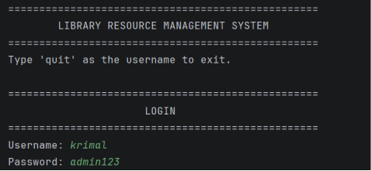
Description:
Shows the authentication process where users enter their username and password to access the system.

A.2 Main Menu
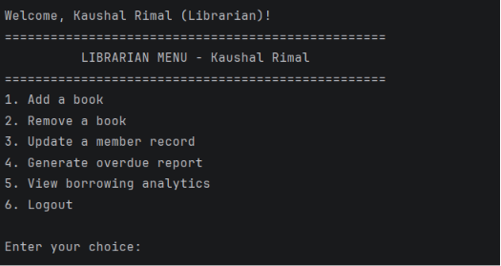
Description:
Displays the available options after successful login based on the user's role.

A.3 Book Management
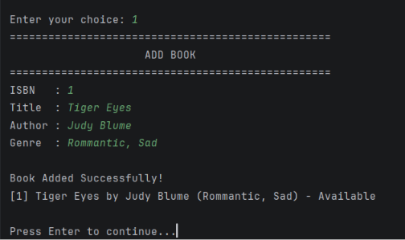
Description:
Demonstrates librarian functionality for managing library resources.

A.4 Member Management
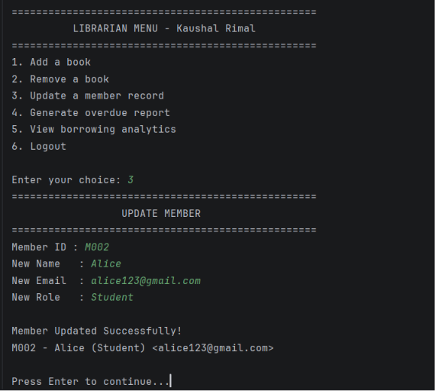
Description:
Shows how member information is stored and managed.

A.5 Borrow and Return Operations
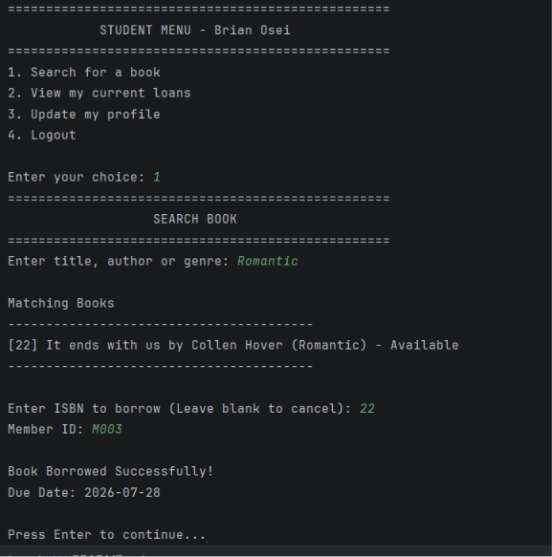
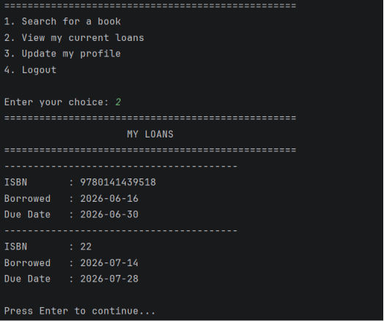
Description:
Demonstrates how the system records book transactions.

Appendix B: Sample Data Files
books.txt
Example:
B001, Python Programming, John Smith,978123456789, Available
B002, Data Science Basics, James Brown,978987654321,Borrowed

members.txt
Example:
M001, Abhipsha, Librarian
M002, Student01, Student

loans.txt
Example:
Student01, B001, Borrowed
Student02, B002, Returned

passwords.txt
Example:
librarian01, hashed_password_value
student01, hashed_password_value

Appendix C: GitHub Repository
Project Repository:
https://github.com/babhipsha/FODS-Project-Work
The GitHub repository contains the complete source code, project modules, and supporting files used to develop the Library Resource Management System.

Appendix D: Additional Evidence
Additional evidence may include:
- Source code files.
- Test results.
- Flowcharts.
- UML diagrams.
- Presentation slides.
- Development notes.
These materials support the implementation and evaluation of the completed project.

